**Phase 4 : Project Development Part 2**

**Project title:**

Machine learning model deployment with IBM cloud Watson Studio.

**Problem Statement:**

Become a wizard of predictive analytics with IBM Cloud Watson Studio. Train machine learning models to predict the outcomes in real time. Deploy the models as web services and integrate them into your applications. Unlock the magic of data driven insights and make informed decidions like never before.

**Contents of the document:**

* + Installing the required libraries
  + Adding Watson Machine Learning service credentials to access
  + **WatsonMachineLearningAPIClient**library
  + Storing the model in WML repository
  + Web service

**Project Overview:**

House Price Prediction Analysis aims to use Machine learning analysis algorithms to predict the price of houses based on their features like number of rooms, number of bedrooms, age of the house, population of the respective area where the house is located, location of the house and the area income with other relevant factors if available.By this Machine Learning model user can predict the price of the house that can be sold.

**Step:1**

Install ibm_watson_machine_learning by the command

**#pip install ibm_watson_machine_learning**

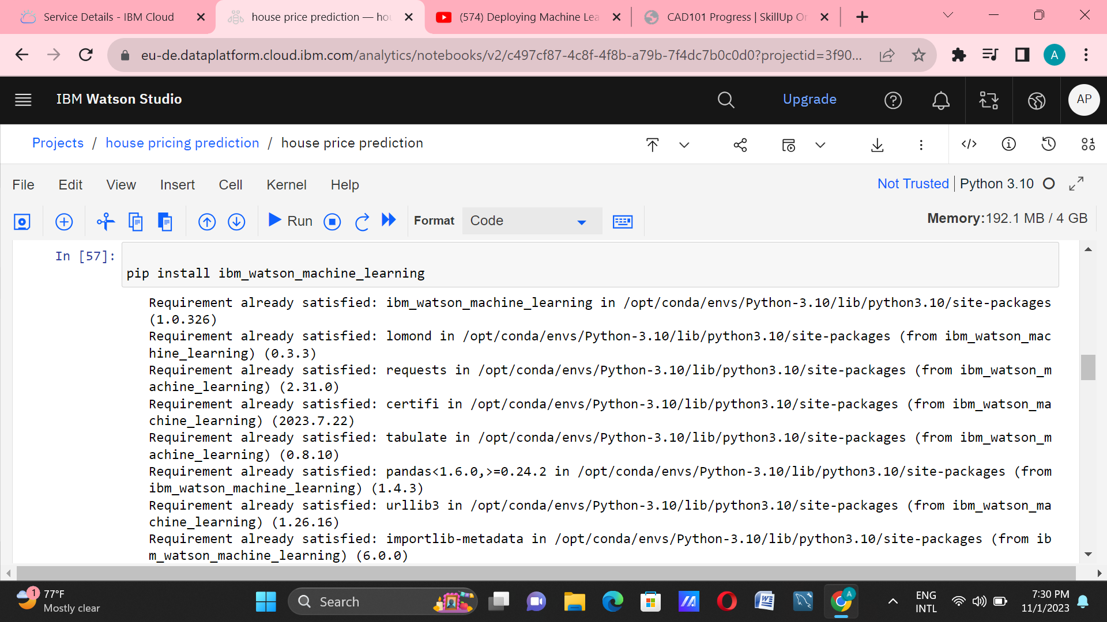**Step 2:** Import **WatsonMachineLearningAPIClient**library. Watson studio uses Watson Machine Learning service credentials to access WML service, so paste the credentials.

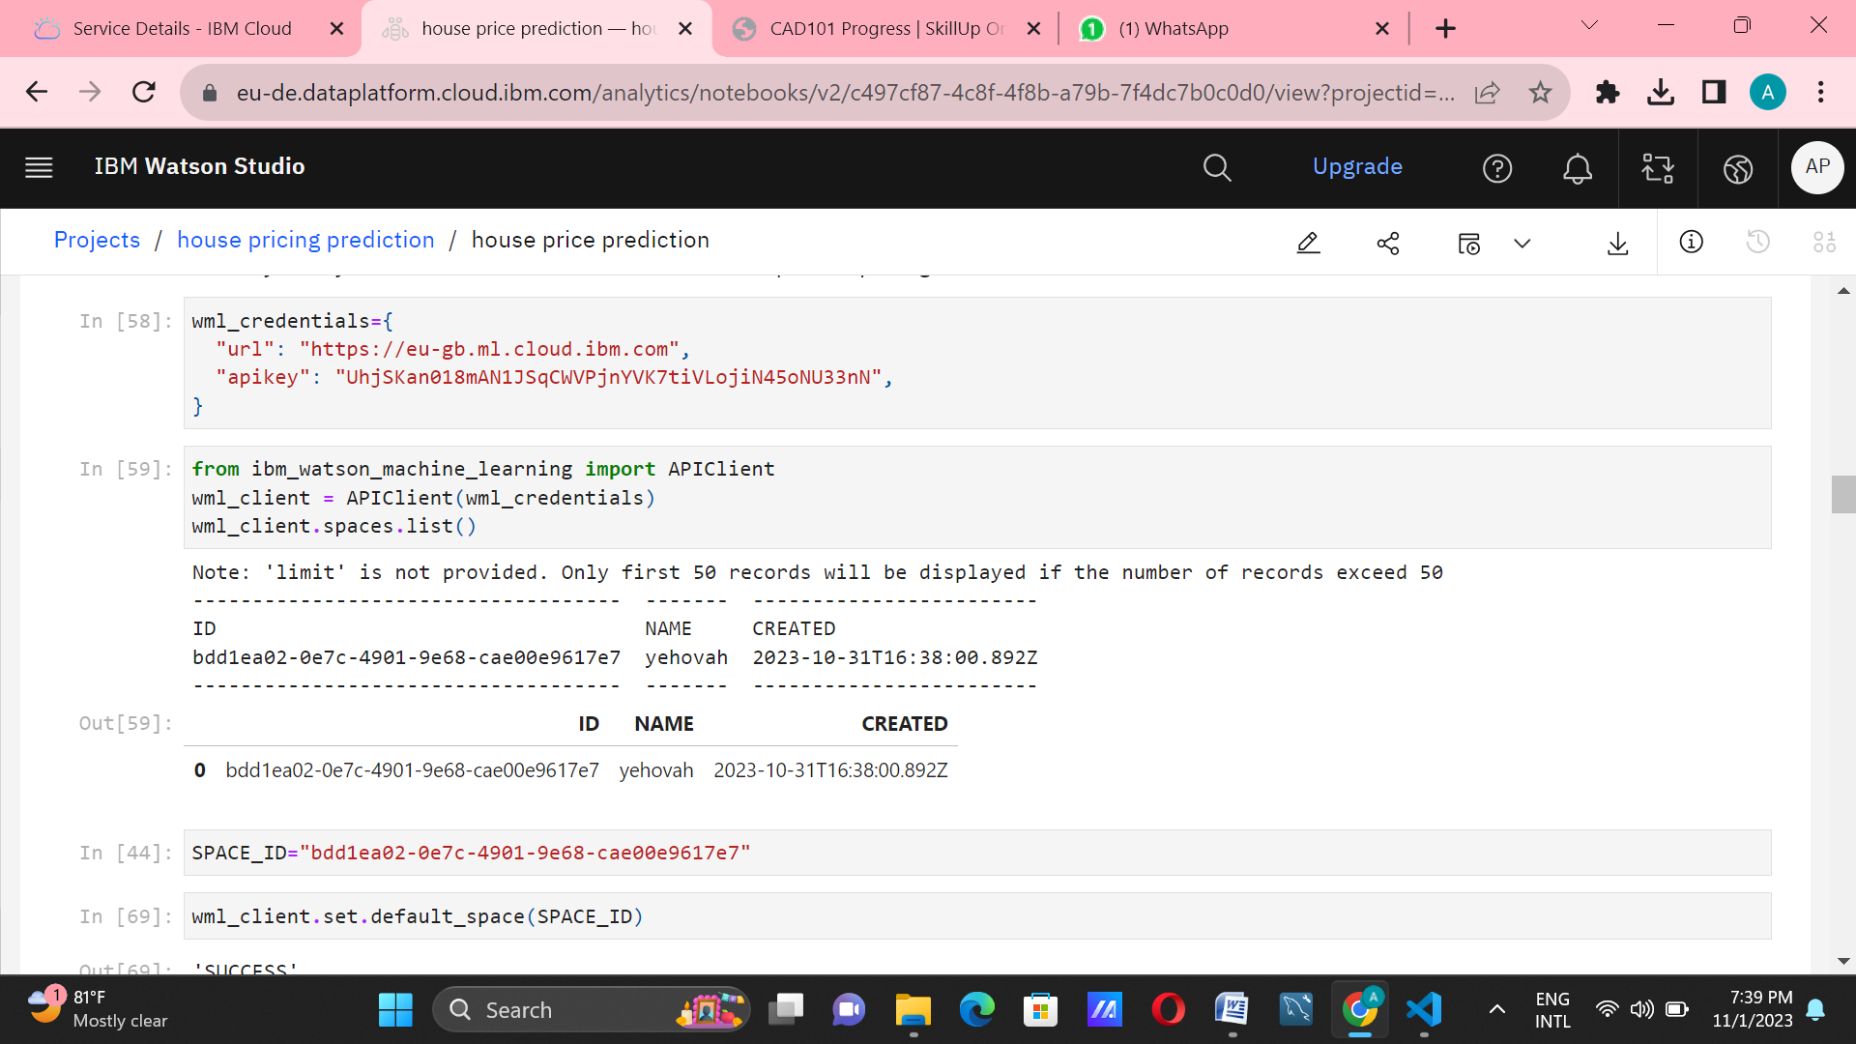

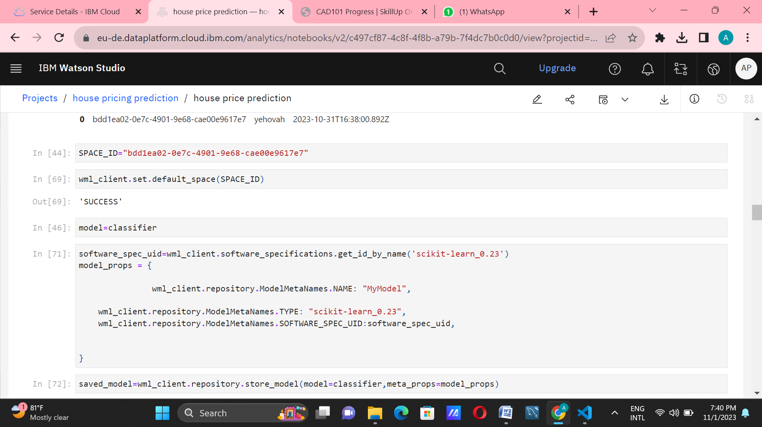**Step-3:**In this step we have to specify our machine learning model properties and store the model in WML repository.

**Step :4**

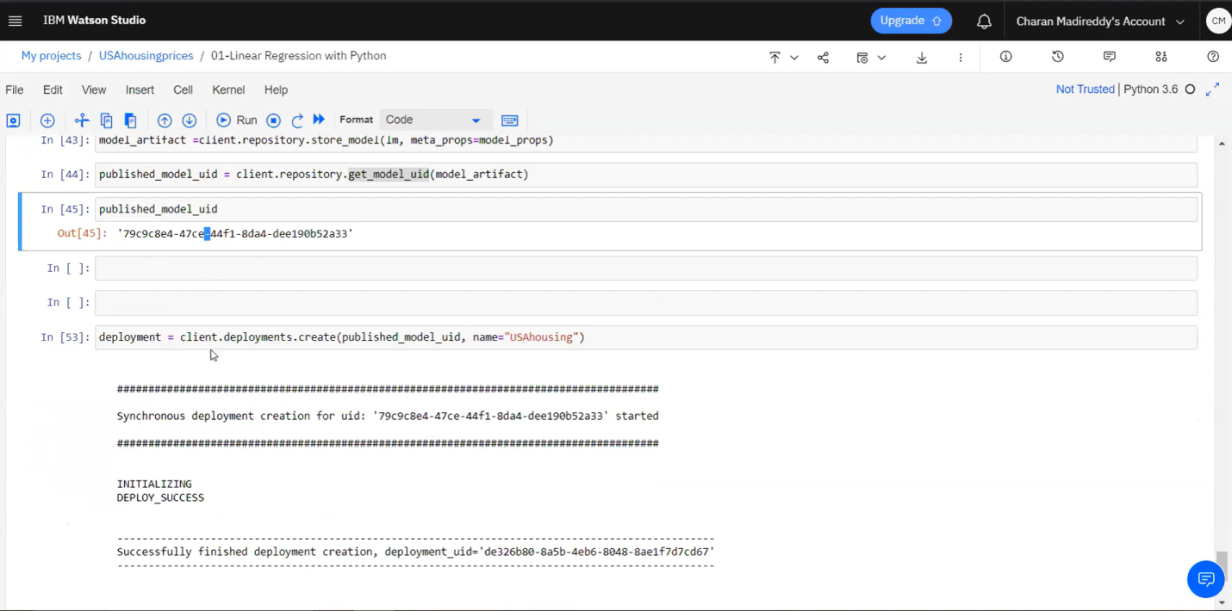 Successfully we have deployed our model in IBM Watson Studio.

**Step 5:** Now we have deployed our machine learning model as a Web service. Once the model is deployed ,it can be used to make predictions or provide other intelligent services to web users.

